Additional Information for Claiming Examination Fees and Expenses

Eligibility for payment of fees
University Teaching Officers are not due any payment, except for:
- Associate Lecturers who receive no stipend from the University
- Those examining research degrees: Ph.D, M.Litt, M.Sc., Eng.D, Ed.D., M.D., Vet.M.D, M.Chir. BusD, MPhil by thesis and oral only, Graduate Diplomas by thesis and oral only, and Higher Doctorates.

Payment to UG internal examiners and assessors
Payment for work carried out from 1st January 2023 onwards is paid via CCWS. Any queries on this can be directed to casual.workers@admin.cam.ac.uk

Preparation time for multiple parts of a UG Tripos or PG Taught Mphil
Where examiners/assessors examine more than one exam part, the general rule is that preparation time can only be claimed once.
However if Departments confirm that preparation time was actually spent on each exam part, then preparation time can be claimed accordingly.
Similarly, if examiners/assessors prepare papers that are shared by different exam parts, preparation time can only be claimed once.

Taxation
For undergraduate (Lower) examinations, Examiners and Assessors are treated workers. Therefore, tax may be deducted from the payment (see pages ESM4150 and ESM4151 of the UK Employment Status Manual). To make sure that the correct amount of tax is deducted, either a P45 or Starter Checklist must be submitted with the Examiner Claim Form.
For postgraduate Research and Higher Degree examinations, Examiners and Assessors are treated as self-employed. Those claiming for payment in these instances are responsible for any liability and payment of tax arising from these payments (as stated in the signed declaration).

External Examiner Report
Payment to external examiners of Undergraduate and Postgraduate Taught examinations will only be processed following receipt of the External Examiner report by the Vice Chancellor office (vcexternalexaminers@admin.cam.ac.uk)

Guidelines for the Repayment of Expenses
Expenses within guidelines are repaid in full. Examiners are asked to cover and reclaim expenses, providing receipts with this form. Reimbursements for expenses above the limits set out below or submitted without receipts are not guaranteed without prior approval.

Travel Expenses

Examiners are required to use the most cost-effective form of transport.

External Examiners who are required to attend in-person, may claim travel expenses to cover their transport between their normal place of residence and Cambridge (or, if the examination is held elsewhere, the location of the examination) as outlined below.

- Internal Examiners, required to travel from Cambridge, when the oral examination is held elsewhere, may claim travel expenses as outlined below.
- Rail: Claims may not exceed the return fare at the best pre-booked standard rate available between the Examiner's normal place of residence and Cambridge (or the examination location, if held elsewhere). Tickets should be for second class travel.
- Car: Travel expenses may be claimed at the rate of 45p per mile up to 10,000 miles and 25p per mile thereafter.
- Taxi: Long distance taxi fares from airports (e.g. Stansted, Heathrow) cannot be claimed from central resources.
- Air: External Examiners from outside the UK and those from certain parts of the UK may claim return economy airfares where absolutely required and after discussion with and approval by the Degree Committee. Such approval must be attached to the Claim Form.

Subsistence

Subsistence expenses may be claimed at the rates below:

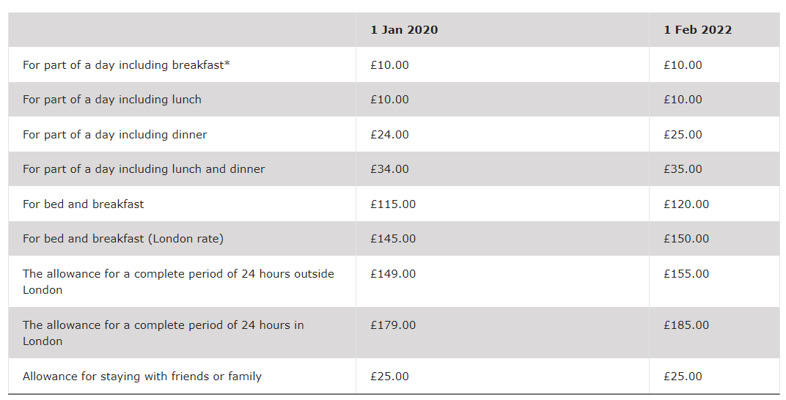

No payment may be made in respect of a day or night on which an Examiner's absence from their normal place of residence is unnecessary. All claims must be supported by a receipt.

Note for Internal Examiners:

- Expenses cannot be claimed for entertaining students or supervisors, under any circumstances.
- Entertainment expenses cannot be claimed for members of an MPhil Examination Committee except for the personal expenses of the External Examiner
- If the Internal Examiner entertains the External Examiner over a meal, this may be claimed at the ‘dinner’ rate. When submitting a claim for entertainment expenses for another Examiner, please give details of persons included in the claim and make an appropriate reduction for any part of the bill not eligible to be reimbursed.

External Examiners requiring overnight accommodation are advised to consult the Head of the appropriate Department/Faculty as it may be possible to arrange accommodation in a College or at certain hotels at which the University has negotiated a preferential rate. Accommodation costs should not exceed one night in normal circumstances.

Note for Departments booking accommodation on behalf of an Examiner:
Please pay the accommodation invoice and recharge Student Registry (CUFS customer no. 1002) via IDN. The IDN will need to be sent to Student Registry along with a copy of the completed examiner claim form. Without the examiner claim form, which includes all the details of the examination, Student Registry will not be able to pay the internal invoice

Other Expenses

Claims may be made for any reasonable expenses incurred by an Examiner in the undertaking of their duties; e.g. costs of postage, printing and the typing of reports.
Printing costs will only be reimbursed to external examiners at a rate of 5p per page.

If you require advice about the nature and level of fees and expenses to be claimed, please contact: feeandexpenseclaims@admin.cam.ac.uk

Other information
Examiner work during parental leave (for University employees):
Paid examination work cannot be carried out during parental leave. The payment cannot be processed as a KIT (Keep in touch) day, as this is only allowed for work that is relevant to the normal contract of employment.

