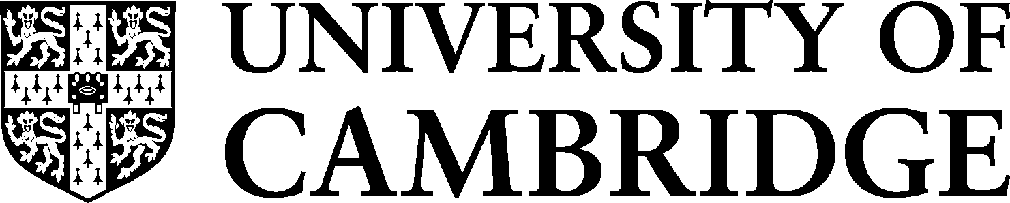
ADJUSTED MODE OF ASSESSMENT STUDENT DECLARATION FORM
Contact: exam.arrangements@admin.cam.ac.uk

DECLARATION

I confirm that I give my consent for the enclosed supporting medical and / or specialist evidence to be submitted by my College, and made available, on a confidential basis, to members of a case conference formed to consider an Adjusted Mode of Assessment. Following a case conference, the supporting medical and / or specialist evidence will be provided to the medical advisers of the Examination Access and Mitigation Committee to approve any request for an Adjusted mode of Assessment.

Only members of the case conference and medical advisers of the Examination Access and Mitigation Committee will have access to this medical and / or specialist evidence.

YES | NO

The University undertakes to handle this information carefully in accordance with the requirements of data protection legislation and will not divulge its contents to any third party or use it for any other purpose without your further consent. General details about the University’s use of personal information are published at https://www.information-compliance.admin.cam.ac.uk/data-protection/general-data-protection-regulation

I understand that the medical and / or specialist evidence will form my application for an adjusted mode of assessment.

Name (Block Caps)
College
Signature
Date

You should complete and return this form to your College/Postgraduate Tutor who will send it, on your behalf together with a copy of the application and supporting medical and / or specialist evidence.

V.6.0 September 2022

